St.JOSEPH’S COLLEGE OF ENGINEERING, CHENNAI -119
St.JOSEPH’S INSTITUTE OF TECHNOLOGY, CHENNAI-119
MA 6351 - TRANSFORMS AND PARTIAL DIFFERENTIAL EQUATIONS
ASSIGNMENT – V

UNIT I PARTIAL DIFFERENTIAL EQUATIONS
PART-A

1. | Form the partial differential equation by eliminating the arbitrary constants ‘a’ & ‘b’ from  z= (x²+a)(y²+b)
2. | Form the partial differential equation by eliminating f from 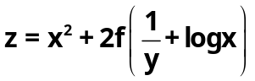.
3. | Form the partial differential equation by eliminating g from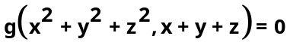.
4. | Find the singular integral of 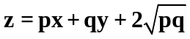
5. | Solve 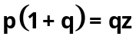.
6. | Solve 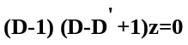
7. | Solve 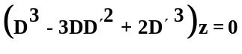.
8. | Find the particular integral of 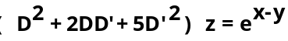
 | PART – B
1. | a) | Solve 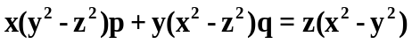
 | b) | Solve 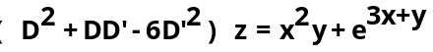
2. | a) | Find the singular solution of the equation 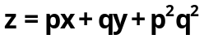
 | b) | Solve
3. | a) | Find the singular solution of the equation 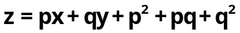
 | b) | Solve
4. | a) | Solve 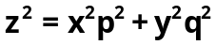
 | b) | Solve 